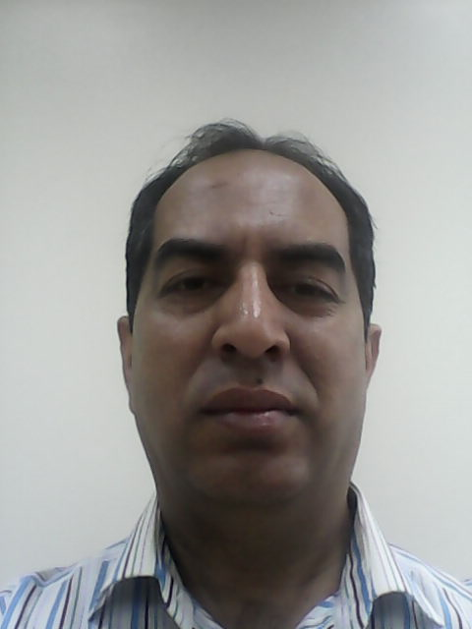
CURRICULUM VITAE
A: Personal Information
Name: -----Syed Asad Haider Jaffri-------------------
Specialization --- ELT----------------------------------
Highest Degree ----M.A. (English)-----------------------------------
Academic Rank ----Language Instructor---------------------------
Email ----s_asadjafary@hotmail.com------------------------------
B: Qualifications
1. M.A. English------------------------------------------------------
2. Dip. In TEFL------------------------------------------------------
3. B.Ed.---------------------------------------------------------------
C: Teaching experience at the university
11 Years -------------------------------------------------------------
D: Publications
--------------------------------------------------------------------
E: Committees
-------------------------------------------------------------------------------
F: Community Service
-------------------------------------------------------------------------------
G: Courses taught
R140, L&S142-------------------------------------------------------------
H: Membership of scientific societies
-------------------------------------------------------------------------------
I: Training Courses
-------------------------------------------------------------------------------
J: Conferences, workshops and symposia
-------------------------------------------------------------------------------
-------------------------------------------------------------------------------

