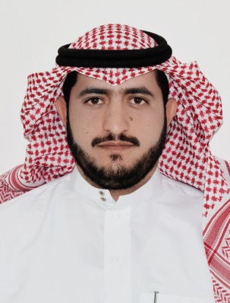
CURRICULUM VITAE
A: Personal Information
Name: Mohammad Saeed Ali Al-Ahmari
Specialization English
Highest Degree Master
Academic Rank Language Instructor
Email msa126@hotmail.com
B: Qualifications
Master degree in English Language and Translation
Bachelor degree in English

C: Teaching experience at the university
4 years

D: Publications
-------------------------------------------------------------------------------
E: Committees
- Academic Advising
- Scholarships Unit

F: Community Service
Professional Vocabulary for Administrative.
G: Courses taught
- Reading skills
- Writing skills
- Listening & Speaking skills
- Technical Report Writing
- General English
H: Membership of scientific societies
-------------------------------------------------------------------------------
I: Training Courses
- Teaching English.
- Management of Student's in Classes.
- Effective Academic Advising
- Using Computer in University
J: Conferences, workshops and symposia
- Strategies of exams
- Methods of Teaching English.
- The most effective ways to deal with weak students.

