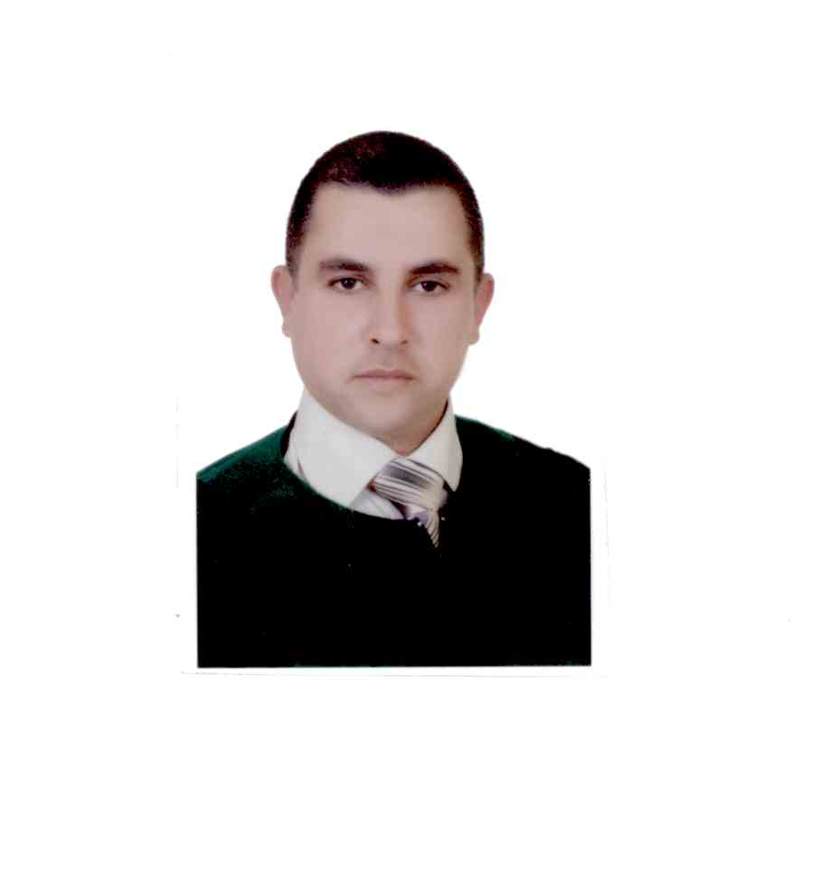PHOTO
CURRICULUM VITAE
A: Personal Information
Name: “Mohammad Khair” Atallah Al-Hourani
Specialization English Language ( Applied Linguistics)
Highest Degree Master
Academic Rank language Instructor
Email mkalhourani@yahoo.com
B: Qualifications
Bachelor degree in English- 1998-2002 /Jordan University of science and Technology-Jordan
Master in English (Applied Linguistics)2008-2009 /University Utara of Malaysia (UUM) – Malaysia
C: Teaching experience at the university
8 years
D: Publications
NONE
E: Committees
Students Activities Committee
F: Community Service
Enhancing Reading Skills Strategies Workshop/ AL-Ahnaf Bin Qays Secondary School
Najran District Education Administration 15/3/14389
G: Courses taught
Grammar ,Writing, Listening and Speaking, Reading, General English, Technical Report Writing

H: Membership of scientific societies
NONE

I: Training Courses
NONE
J: Conferences, workshops and symposia
Modern Trends in Teaching –Workshop
Competitive Research Projects Writing- Workshop
Examination systems and student Assessment- Workshop
The Evaluation Process: Foreign Language Learning/Teaching in the Context
Competitive Research Projects Writing- Workshop
Course description according to the model of National Commission for Academic Accreditation & Assessment- Workshop

