PHO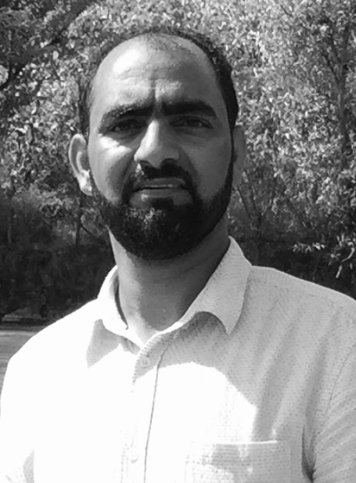TO
CURRICULUM VITAE
A: Personal Information
Name: Bilal Ahmad Itoo
Specialization: English ELT
Highest Degree: Masters
Academic Rank: Lecturer
Email: bilalelt@gmail.com
B: Qualifications
[Pursuing PhD fro CPU/India]

[UK Srinagar/India] — [B.Ed/2007]

[AMU/India] — [Masters ELT/2005]
[AMU/India] — [PG Diploma Linguistics]

[AMU/India] — [Graduation/2003]
C: Teaching experience at the university

[Lecturer] — [Najran university/Saudi Arabia] [24/08/2007] — [till date]
D: Publications
[Evaluation of Listening and Speaking Syllabus in EFL Situation at the Preparatory Program]
[Problems of Spelling in Common English Learners of Saudi Arabia and Strategies for Improvement: A Case Study in Preparatory Year, Najran University, KSA]
G: Courses taught
All LSRW, and Integrated English courses
I: Training Courses
E-learning

