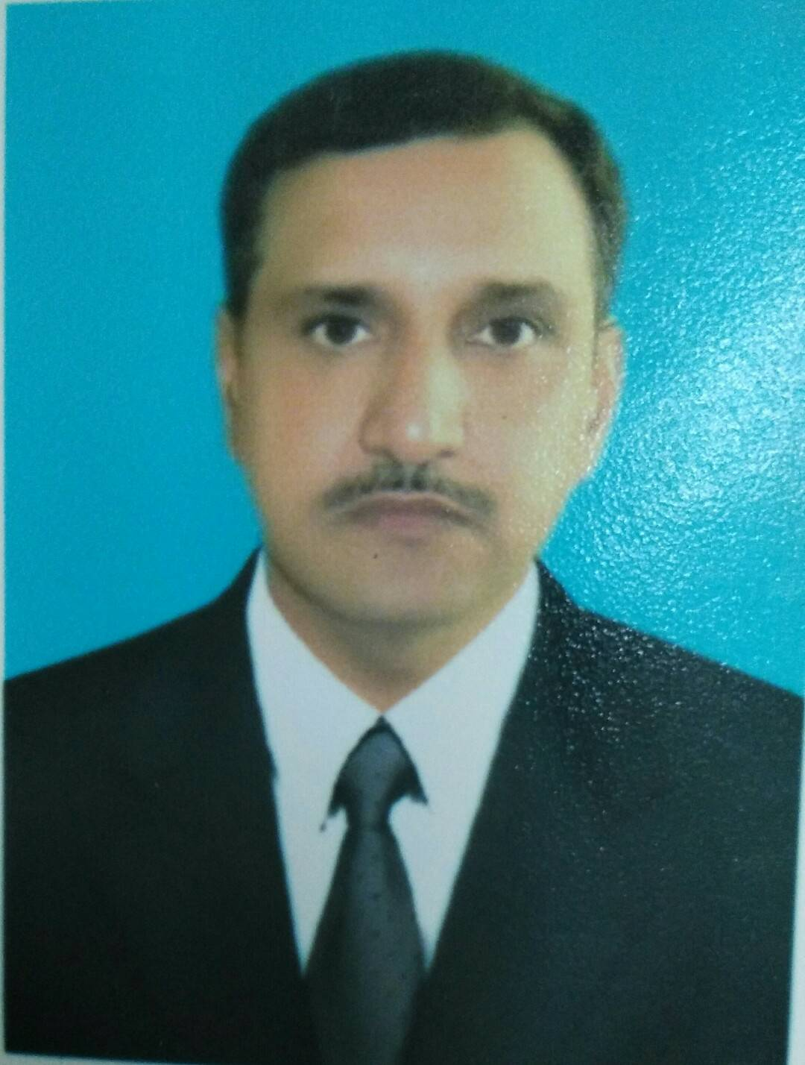PHOTO
CURRICULUM VITAE
A: Personal Information
Name: Jaffar Iqbal-----------------------------------------------------
Specialization ELT-------------------------------------------------------
Highest Degree M.A (English) -------------------------------------------------------
Academic Rank Lecturer-------------------------------------------------------
Email jaffar_iqbal@hotmail.com-------------------------------------------------------
B: Qualifications
M.A (English) -------------------------------------------------------------------------------
Dip.TEFL -------------------------------------------------------------------------------
B.Ed.-------------------------------------------------------------------------------
C: Teaching experience at the university
9 Years-------------------------------------------------------------------------------
D: Publications
-------------------------------------------------------------------------------
E: Committees
-------------------------------------------------------------------------------
F: Community Service
-------------------------------------------------------------------------------
G: Courses taught
R-140 , W-141-------------------------------------------------------------------------------
H: Membership of scientific societies
-------------------------------------------------------------------------------
I: Training Courses
-------------------------------------------------------------------------------
J: Conferences, workshops and symposia
-------------------------------------------------------------------------------
-------------------------------------------------------------------------------

