CURRICULUM VITAE

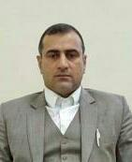
A: Personal Information

Name: Zaheer Ahmed Beig

Specialization E.L.T

Highest Degree Masters

Academic Rank Language Instructor

Email zaheer.beig786@gmail.com

B: Qualifications

M. A in English Language Teaching

C: Teaching experience at the university
6 Years

