PH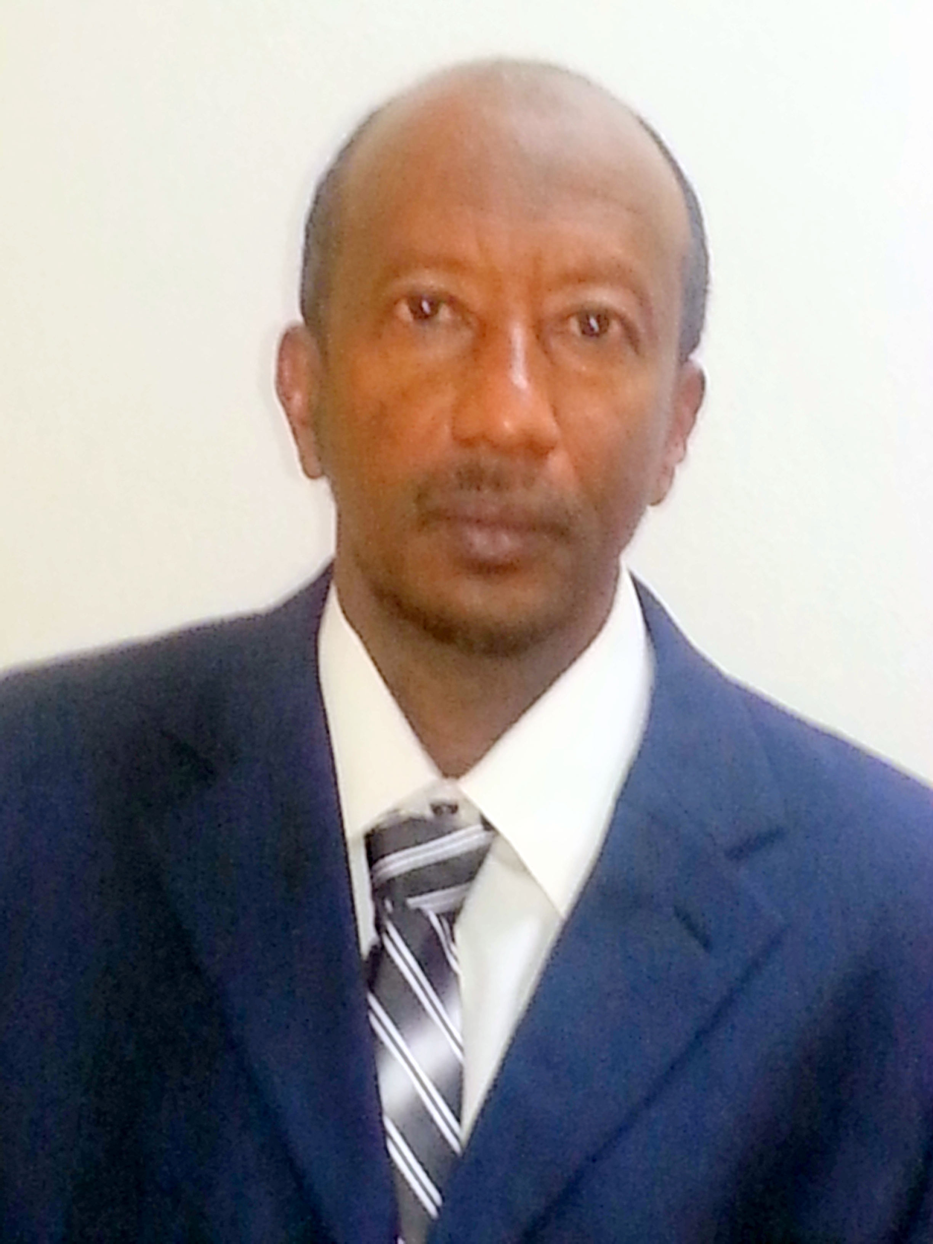OTO
CURRICULUM VITAE
A: Personal Information
Name: --Ali Hamza Ali Hamza
Specialization : Applied Linguistics
Highest Degree : Master in ELT
Academic Rank: Language Instructor
Email : alihamzan2@gmail.com
B: Qualifications
-Bachelor in Education –in English Language Teaching
Master Degree in Applied Linguistics –English Language Teaching
C: Teaching experience at the university:
--Six Years
D: Publications:
E: Committees
-Planning Committee –Community Service Committee
F: Community Service
-A member of Community Service and I participated in presentations
G: Courses taught
Grammar 143, Writing 141 , Listening & Speaking 142, Reading 140, General English 150 , Technical Professional Writing151
H: Membership of scientific societies
I: Training Course
Applications of Cloud Computing-, Structure and Administration of Researching Team
J: Conferences, workshops and symposia
The role of university in community service , The effective ways for teaching grammar, Discrete and integrated skills, Reading Challenges.

