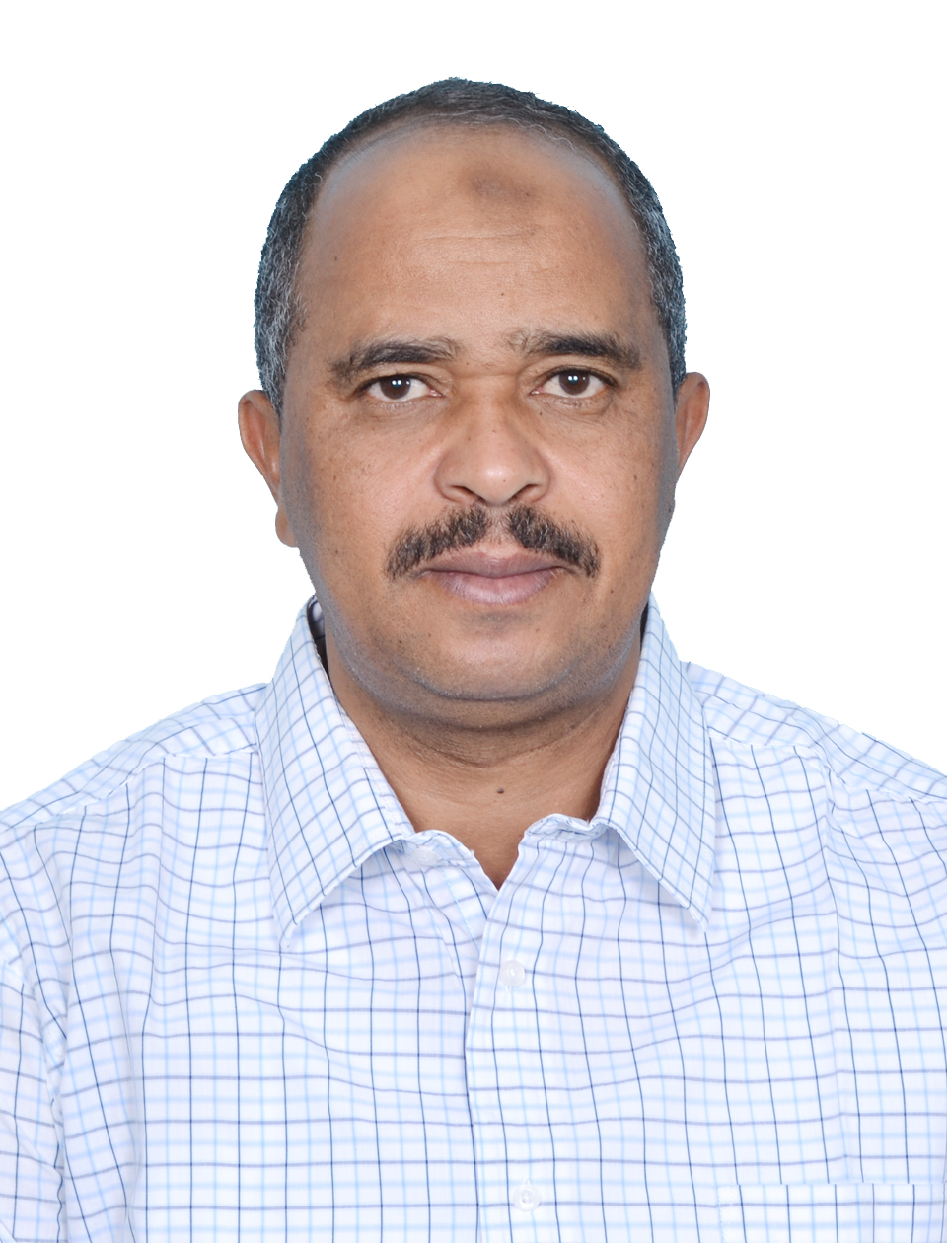
CURRICULUM VITAE
A: Personal Information

Name: MUHIEDDIN MOHD AHMED MOHD ELNAIM
Specialization APPLIED LINGUISTICS
Highest Degree MA. in ELT + ( PhD. CANDIDDATE )
Academic Rank LECTURER
Email mohidnaim67@gmail.com
B: Qualifications
PhD. Candidate 2016
MA. in ELT ( 2008 )
C: Teaching experience at the university
9 Years – Since 1430 H
D: Publications
The Effects of Informal Use of Computer-Mediated Communication on EFL Learner Interaction
DOI:10.3968/j.sll.1923156320120503.801
The Impact of Raising Phonological Awareness on Improving EFL Learners Reading Comprehension: A Case Study at Preparatory Year Najran University
(www.eajournals.org)
E: Committees
- Registrar Unit
- Scheduling unit
- Examination committee
- Performance Assessment & Evaluation Committee
F: Community Service
Membership of SVP
Rural development ( PLAN )
G: Courses taught
- ESP
- General English
- Grammar
- Reading
- Technical Report writing
- English pronunciation
- Listening & Speaking 3
H: Membership of scientific societies
None
I: Training Courses
E-leaning Applications
EFL strategies
J: Conferences, workshops and symposia
- STRENGTHENING ENGLISH STRENGTHENING KNOWLEDGE – 2008 KHAROUTM SUDAN
- E- LEARNING APPLICATIONS –2014 RIYADH -SAUDI ARABIA

