CURRICULUM VITAE

A: Personal Information
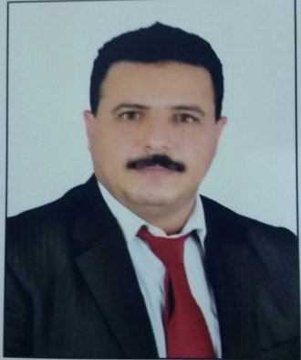PHOTO

Name: Khaled Nasser Ali Al-Mwzaiji
Specialization Applied Linguistics

Highest Degree Ph.D.

Academic Rank Assistant Professor
Email khaledknm@yahoo.com
B: Qualifications
- Doctor of Philosophy, Centre for Applied Linguistics and Translation Studies, School of Humanities, Central University of Hyderabad, Hyderabad, India, 2010;
- Master of Arts, Linguistics, Department of Linguistics, Aligarh Muslim University, Aligarh, India, 2000;
- B.Ed. (Hon), English Language Studies, Faculty of Education, Sana'a University, Sana’a, Yemen, 1993.
C: Teaching experience at the university
- Sep. 2014 – Until now as Assistant Professor of English Language, Department of English, Preparatory Year Deanship, Najran University.

D: Publications
Romantic Forgotten Orientals (Book Translated from Arabic into English).
E: Committees
- English Department Council
- Program Quality Assurance Management Committee
- Translation Committee
- Academic Advisor for English Department
- Academic Supervisor of Listening & Speaking skills
- Academic Supervisor of Grammar

F: Community Service
- Professional Vocabulary for Administrative Affairs, 2018.
- English Terms in Employees' Development and Promotion, 2018.
- Modern ways for Teaching English, 2017.

G: Courses taught
- ENG. 325 Translation II
- ENG. 140 Reading
- ENG. 141 Writing
- ENG. 142 Listening and Speaking
- ENG. 143 Grammar
- ENG. 150 General English

H: Membership of scientific societies
- Australian Systemic Functional Linguistics Association, (ASFLA), 2008, Australia.

I: Training Courses
- Using Google for Academic Purposes. November, 2018.
- Using Blackboard for Exam and Assignments, October 2018.
- Product vs. Process Approach: Teaching Writing in Context, 2017.
- Teaching Reading Comprehension to EFL Students: Challenges of the Current Textbook, 2017.
- Stages of Test Construction: An Assessment of Process & Product, 2017.
- Teaching English Grammar Effectively in an EFL Class, 2017.

J: Conferences, workshops and symposia
- How to Guide Get Published, SDL, October, 2018.
- Publication in International Journal, Najran University, 2018.
- Testing and Evaluation: Course Content and Learning Objectives/Outcomes, Najran University, 2017.
- Skills of Scientific Supervision on Theses and Dissertations, Najran University, 2016.
- Competitive Research Projects, Najran University, 2016.
- Dealing with Individual Differences among Students: Skills and Abilities, Najran University, 2016.
- Development and Assessment of Outcome Based Education System, Najran University, 2016.
- Teaching Strategies based on Students’ Learning Outcomes, Najran University, 2015.
- International Seminar on Endangered and Indigenous Languages, Central University of Hyderabad, 2008.
- International Workshop on Language, Culture, and Translation, Central University of Hyderabad, 2007.

