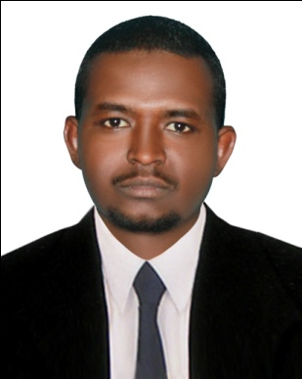
CURRICULUM VITAE
A: Personal Information
Name: ABUQASIM MOHAMMED IBRAHIM
Specialization: ENGLISH LANGUAGE
Highest Degree: MA.
Academic Rank: LANGUAGE INSTRUCTOR
Email : gasimthwra@yahoo.com
B: Qualifications
- MA in General Translation.
- Post Graduate Diploma in General Translation.
- Honors Bachelor of Arts and Education.
C: Teaching experience at the university
- Three Years .
D: Publications
-------------------------------------------------------------------------------
E: Committees
- Translation Committee.
F: Community Service
- Communication Skills in English Language.
G: Courses taught
Reading-140 , Writing-141 , Listening & Speaking- 142 , Grammar-143 , General English -150 , Technical Writing – 151 .
H: Membership of scientific societies
-------------------------------------------------------------------------------
I: Training Courses
- Teaching English as a Second Language .
- Foreign Language Learning .
- English Language Teaching Methodology .
- Journalistic Translation .

J: Conferences, workshops and symposia
- How to Develop Interest among PYP Student to Speak English.
- Teaching English Grammar Effectively in an EFL Class.
- Product vs. Process Approach: Teaching Writing in Context.
- English Language as a Global Language.
- Aptitude and Motivation in Second Language Acquisition.
- Stages of Test Construction: An Assessment of Process & Product

