PH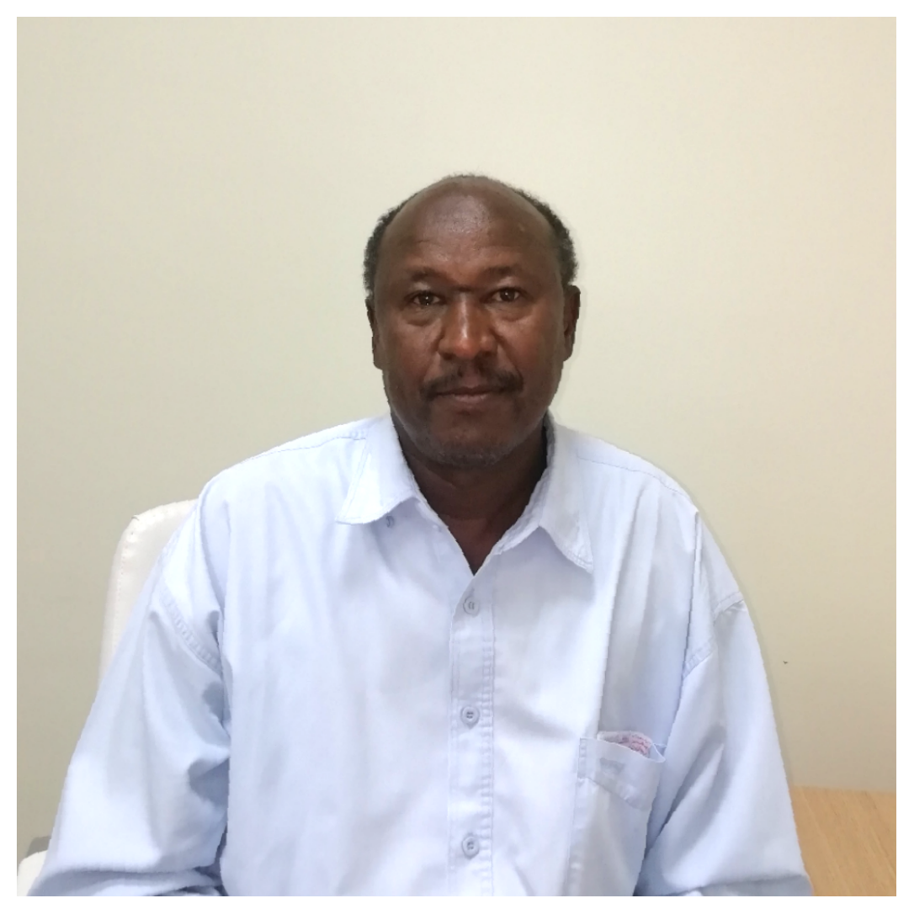OTO
CURRICULUM VITAE
A: Personal Information
Name: Babiker Hussein khalifa Elradi--------------------------------------------------
Specialization --English Language teacher----------------------------------------------------
Highest Degree -Master------------------------------------------------------
Academic Rank ----language instructor---------------------------------------------------
Email --babak5203@gmail.com-----------------------------------------------------
B: Qualifications
Master in Applied Linguistics----(2014--)-------------------------------------------------------------
Bachelor in English language and its literature---(1996)-------------------------------------------
Medium Diploma in translation----(1992)----------------------------------------------------------
C: Teaching experience at the university
Two years-------------------------------------------------------------------
D: Publications
-------------------------------------------------------------------------------
E: Committees

F: Community Service
Yes I’m in Community service---------------------------------------------------------------------
G: Courses taught
1/Writing (141) 2/ Grammar (143) 3/ Technical Writing
H: Membership of scientific societies
-------------------------------------------------------------------------------
I: Training Courses
-------------------------------------------------------------------------------
J: Conferences, workshops and symposia
I attended some workshops Concerning Work’s developing

