**P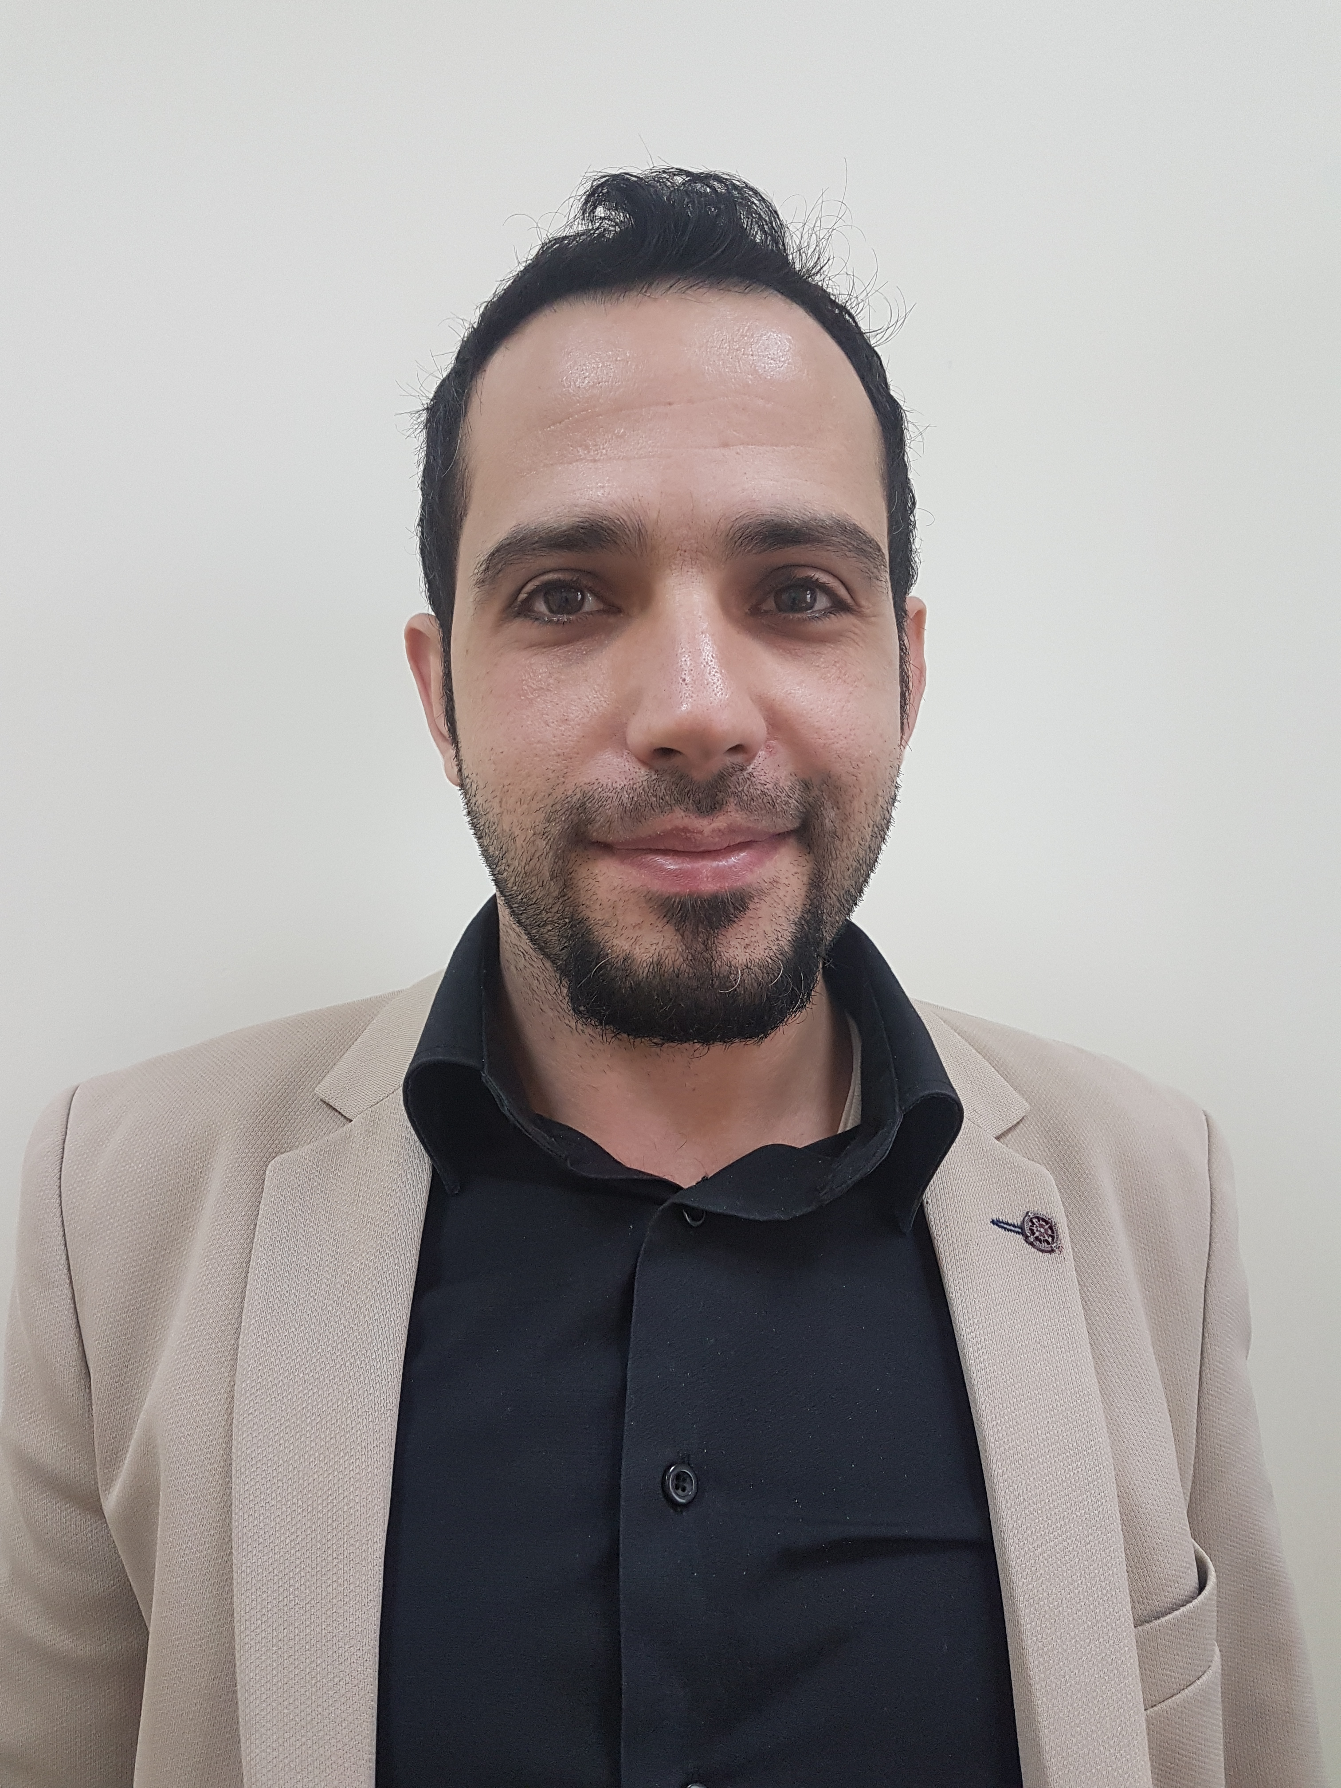HOTO**

**CURRICULUM VITAE**

**A: Personal Information**

**Name:** Ahmad Mohammad Al-Batayneh

**Specialization English Language (Linguistics)**

**Highest Degree Master's**

**Academic Rank language Instructor**

**Email ahmadbatayneh@yahoo.com**

**B: Qualifications**

**Bachelor's degree in English- 2002- 2006 /Yarmouk University**

**Master's in English (Linguistics)2006-2011 /Yarmouk University**

**C: Teaching experience at the university**

**6 years**

**D: Publications**

**NONE**

**E: Committees**

**Students Activities Committee**

**F: Community Service**

**G: Courses taught**

**Grammar ,Writing, Listening and Speaking, Reading, General English, Technical Report Writing**

**H: Membership of scientific societies**

**I: Training Courses**

**J: Conferences, workshops and symposia**

**Modern Trends in Teaching –Workshop**

**Competitive Research Projects Writing- Workshop**

**Examination systems and student Assessment- Workshop**

**Course description according to the model of National Commission for Academic Accreditation & Assessment- Workshop**