CURRICULUM VITAE
A: Personal Information 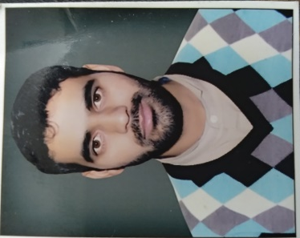
Name: Aadel Yousuf Khanday
Specialization English Literature
Highest Degree M.A (B.Ed)
Academic Rank Language Instructor
Email aadelyk@gmail.com
B: Qualifications
Master of Arts (M.A English)
Bachelor of Education (B.Ed)
Bachelor of Arts (B.A)
C: Teaching experience at the university
Five years
D: Publications
-------------------------------------------------------------------------------
E: Committees
Teacher Assessment (for facilities and equipment)
F: Community Service
Speaking English fluently methods and approaches
G: Courses taught
Grammar, Listening speaking and Writing
H: Membership of scientific societies
-------------------------------------------------------------------------------
I: Training Courses
Attended a presentation about new tools and techniques in micro power point presentation
Attended a training session about E- learning
Attended a training session about cloud computing
J: Conferences, workshops and symposia
Attended a workshop at Jaipur National University about Research Methodology
Attended various workshops at Najran University,
- Integrated & Discrete Skills at PYP
- Stages of Test Construction: An Assessment of Process & Product
- How to create assignments/tests on Bb

