PHO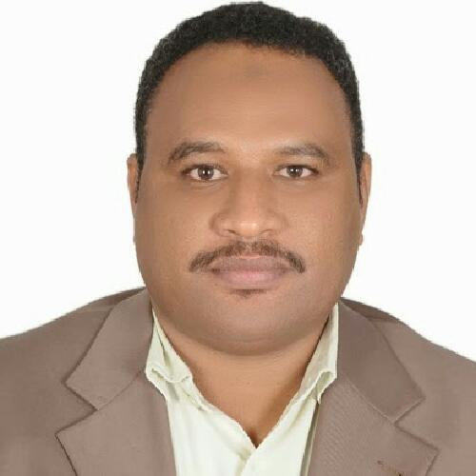TO
CURRICULUM VITAE
A: Personal Information
Name: Nassir mohammed idriss Ahmed
Specialization English Language
Highest Degree Master
Academic Rank Instructor
Email nassirup@hotmail.com
B: Qualifications
MA – Applied Linguistics
-------------------------------------------------------------------------------
-------------------------------------------------------------------------------
C: Teaching experience at the university
2 years.
D: Publications
-------------------------------------------------------------------------------
E: Committees
Facilities and Equipment.
F: Community Service
-------------------------------------------------------------------------------
G: Courses taught
Reading – Writing - Grammar
H: Membership of scientific societies
-------------------------------------------------------------------------------
I: Training Courses
-------------------------------------------------------------------------------
J: Conferences, workshops and symposia
-------------------------------------------------------------------------------
-------------------------------------------------------------------------------

