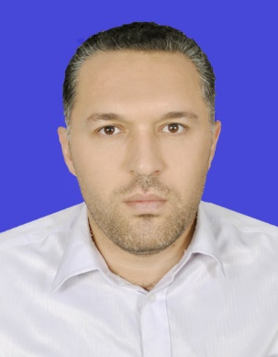
CURRICULUM VITAE
A: Personal Information
Name: Ali Abbas Falah Alzu’bi
Specialization English Language and Translation
Highest Degree Master degree
Academic Rank Language instructor
Email aliyarmouk2004@gmail.com
B: Qualifications
Master degree in English language and translation
C: Teaching experience at the university
10 years
D: Publications
-Alzubi, A. A., & Singh, M. K. (2018). The Impact of Social Strategies through Smartphones on the Saudi Learners’ Socio-cultural Autonomy in EFL Reading Context. International Electronic Journal of Elementary Education, 11(1), 31-40.‏
-Hazaea, A., & Alzubi, A. (2018). Impact of Mobile Assisted Language Learning on Learner Autonomy in EFL Reading Context. Journal of Language and Education, 4(2), 48-58. https://doi.org/10.17323/2411-7390-2018-4-2-48-58
-Alzubi, A. A. F., Manjet, K., & Pandian, A. (2017). The Use of Learner Autonomy in English as a Foreign Language Context among Saudi Undergraduates Enrolled in Preparatory Year Deanship at Najran University. Advances in Language and Literary Studies, 8(2), 152-160.
-Alzubi, A. A. F., & Manjet, K. (2017). The Use of Language Learning Strategies through Smartphones in Improving Learner Autonomy in EFL Reading among Undergraduates in Saudi Arabia. International Journal of English Linguistics, 7(6), 59-79.
-Hazaea, A. N., & Alzubi, A. A. (2017). Effects of CDA Instruction on EFL Analytical Reading Practices. Novitas-ROYAL, 11(2), 88-101.
-Almekhlafy, A. & Alzubi, A. A. F. (2016). Mobile-Mediated Communication a Tool for Language Exposure in EFL Informal Learning Settings. Arab World English Journal, 7(1), 388-407.
-Hazaea, A. N., & Alzubi, A. A. (2016). The Effectiveness of using mobile on EFL learners’ reading practices in Najran University. English Language Teaching, 9(5), 8-21.

E: Committees
Exam committee, registration and timetables, performance assessment and evaluation
F: Community Service
No
G: Courses taught
Reading, Writing, Listening and Speaking, Grammar, Technical Writing, General English
H: Membership of scientific societies
No
I: Training Courses
Blackboard, exam evaluation, reading strategies, and teaching methods
J: Conferences, workshops and symposia
The 7th International Language Learning Conference (ILLC2017), Universiti Sains Malaysia, Penang, Malaysia.
The 4th International Postgraduate Colloquium (INPAC 2018), Universiti Sains Malaysia, Penang, Malaysia.

