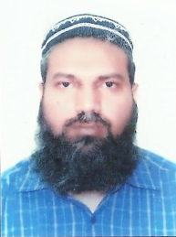
CURRICULUM VITAE
A: Personal Information
Name: ------Adnan Zia ul Hakeem-------------------------------------------------
Specialization ----------English---------------------------------------------
Highest Degree -------------Master’s------------------------------------------
Academic Rank -----------Lecturer/ Instructor--------------------------------------------
Email -------------abumuhammadsa@gmail.com--------------------------------
B: Qualifications
MA (linguistics), MA (English Literature), MPhil
C: Teaching experience at the university
---------------11 years----------------------------------------------------------------
D: Publications
---------------------Nil----------------------------------------------------------
E: Committees
1 (e-learning)
F: Community Service
E learning sessions / volunteering for several community causes-----------------------
G: Courses taught
--Reading/writing/grammar/listening & speaking skills, General English & Technical writing / Vocabulary (at Arts and Science)
H: Membership of scientific societies
--------Nil-----------------------------------------------------------------------
I: Training Courses
E- Learning workshops both as an instructor and as a participant/student
J: Conferences, workshops and symposia
Several professional refresh courses/ symposium in ELT methodology

