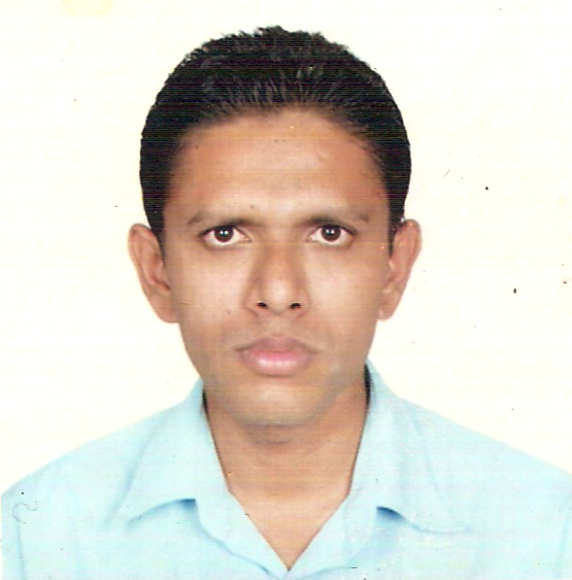
CURRICULUM VITAE
A: Personal Information
Name: --------TAJ MOHAMMAD--------------------------------------
Specialization -----------English--------------------------------------------
Highest Degree -----------Ph.D.--------------------------------------------
Academic Rank -----------------Asst. Professor--------------------------------------
Email ---tajmohd09@gmail.com---------------------------------
B: Qualifications
-------------M.A. English---------------------------------------------------------
--------------TESOL (USA)-----------------------------------------------------------------
--------------Fulbright Fellow-(USA)------------------------------------------
C: Teaching experience at the university
--------------7--------------------------------------------------------------
D: Publications
----------------20---------------------------------------------------------------
E: Committees
------------EXAMINATION----------------------------------------------------------
F: Community Service
-------------------1------------------------------------------------------------
G: Courses taught
---------------6----------------------------------------------------------------
H: Membership of scientific societies
------------------------------------------------------------------------------
I: Training Courses
-----------------4-5-----------------------------------------------------------
J: Conferences, workshops and symposia
----------------15---------------------------------------------------------------
-------------------------------------------------------------------------------

