P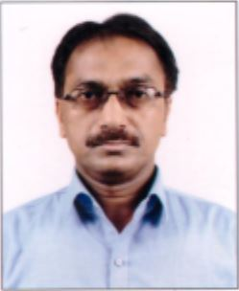HOTO
CURRICULUM VITAE
A: Personal Information
Name: SYED RAIHAN AHMED NEZAMI
Specialization LANGUAGE AND LITERATURE
Highest Degree M. A. (ENGLISH)
Academic Rank LANGUAGE INSTRUCTOR
Email raihan.nezami@gmail.com
B: Qualifications
Master in Arts (ENGLISH), (Magadh University, Bodh Gaya, Bihar, India)
Bachelors in Education, (M.D.U. Rohtak, Haryana, India)
Bachelors in Education, (Magadh University, Bodh Gaya, Bihar, India)
C: Teaching experience at the university
12 years
D: Publications
- The Comprehension Problems of the Saudi students in Reading skill with special focus on PYP, Nejran University
- Panacea of Words: The Formation of Words is an internal process from within
- The Figures of Speech are an integral part of English literature
E: Committees
Course Supervisor (G.E. 150)
F: Community Service
Took part in various programs organized by different organizations in Nejran
G: Courses taught
All Skills – Reading, Writing, Grammar & Listening and Speaking to Level 1 and the integrated course to Level-2 students
H: Membership of scientific societies
N.A.
I: Training Courses
Participated in different training courses at the university level
J: Conferences, workshops and symposia
Participated in various conferences, workshops and symposia at the university level

